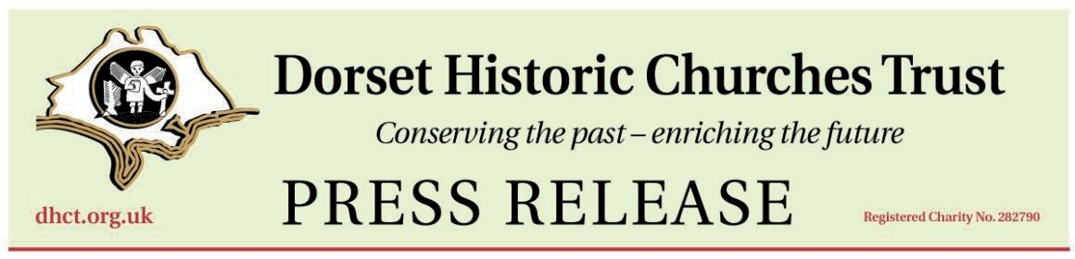

Ride, Stroll, Roll – Your Way!
Everyone is invited to take part in this year’s Ride + Stride on Saturday 12 September, raising money for Dorset’s historic churches, whilst enjoying a great day out. The money you raise is shared between Dorset Historic Churches Trust (DHCT) and a church of your choice, so your participation will help directly with repairs to your local church or chapel.
Traditionally people walk or cycle between churches, sponsored by family and friends but there are many ways to take part. You can travel however suits you – walking, cycling, using an electric scooter or other motorised vehicle or even catching the bus! With many of Dorset’s churches open on the day, participants can plan their own route, set their own pace and make the day as relaxed or adventurous as they like.
The event is open to people of all ages and abilities. Whether you visit one church or several, every journey helps support these important community landmarks.
“Ride + Stride is a wonderful opportunity to spend time outdoors, explore churches you have never visited before, and support an important cause. However you choose to take part, we’d love you to join us,” said ….Church Representative for ….
For information about taking part, sponsoring a participant or volunteering at a church on the day, please contact:…….
An editable version of this form can be found on the Dorset Historic Churches Trust website
for you to edit for your needs. www.dhct.org.uk

President HM Lord Lieutenant of Dorset Mr Michael Dooley LVO FRCOG Hon. DSc Chairman His Honour D E B Grant
Registered Charity No: 282790 Website: dhct.org.uk
Registered Office: Suite 1, Mey House, Bridport Rd, Poundbury, DT1 3QY In association with The National Churches Trust
J
20260327 Press Release V02

